MARY, MOTHER OF GOD, QUEEN OF THE UNIVERSE – PRAY FOR US
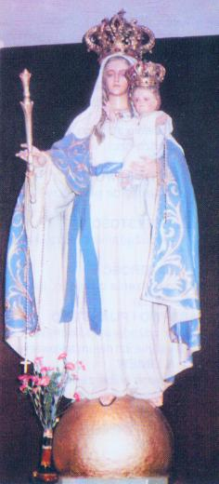
In such a shape Mother Mary appeared before Katarzyna Szymon on 25.07.1954 at Gilowice (Poland). (ang.)

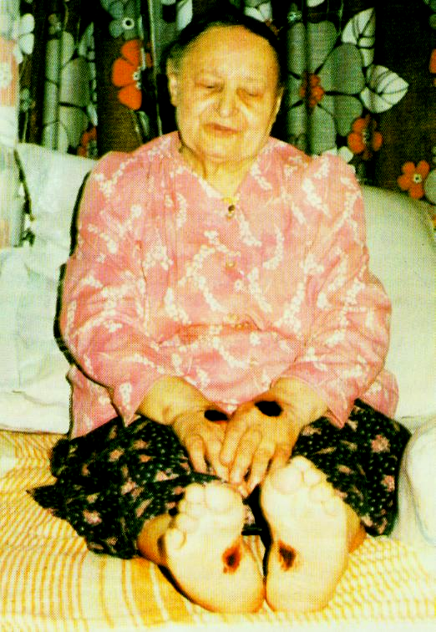
Katarzyna (Cathrine) Szymon – A stigmatic from Poland
Katarzyna Szymon was born on 21.10.1907 in Studzienice. She was christened and received her First Holy Communion n the parish church in Pszczyna. Her mother passed away when she was only a one-year-old baby. Since her early childhood she displayed the gifts of prayer, contemplation and solitude. Only Holy God understood her contrition of heart. On the eighth day of March 1946 she received stigmata on both hands, both feet, under her right breast and on the forehead. She cried with blood-stained tears. She was endowed with many miraculous gifts such as an encounter with Jesus Christ, Saint Mary and other Saints, a gift of being simultaneously at two different places and different times, fathoming out people’s hearts and consciences, speaking foreign languages (including Hebrew and German despite being unable to write and read). Many a time, as witnesses testify, “Holy Communion descended and rested on her very lips”. This very miracle, evidence and other facts can be watched in the film which is available for downloading or viewing free of charge on www.KatarzynaSzymon.pl (com). Stigmata along with sufferings had lasted for 40 years till her death. Heavenly Address she received during her ecstasies is in conformity with the Church’s teachings. Extraordinary humbleness and sufferings she had gone through make the slightest mistake in discerning her charismas impossible. They are a warranty of holiness.In 1983 John Paul II met with her in Katowice, he embraced her and said to the accompanying bishop Bednorz: Look after this person, please. K. Szymon died on Aug. 24, 86. 20000 people attended to her funeral among whom there were many priests. (ang.)
A PRAYER FOR A SOON BEATIFICATION OF KATARZYNA SZYMON
Almighty, eternal God, the Source of all Holiness, I humbly beg you for the grace of raising your servant, the stigmatic Katarzyna Szymon, to the altars, so we may – by following her example and enjoying her support, strengthened by the light and power of the Holy Spirit – become mature Catholics and loyally follow the way of the Cross and suffering to resurrection, in unity with Jesus Christ, our Saviour.
Jesus, our Lord, Good and Merciful, I beg You to grant me – through the support of Your servant Katarzyna Szymon – the grace of (mention the grace you want to ask for …).
One has to say the following prayers thrice: The Lord's Prayer, Hail Mary, Glory to God and His Son and the Holy Spirit…
In August 2001, there were collected about 2200 signatures with a request for launching the process of the beatification of Katarzyna Szymon, and same were submitted with the Metropolitan Curia: Pl-40-953 Katowice, ul. Jordana 39.
We also may provide our own testimony there.

